Task 1:
User should be able to submit form with all required fields filled in
Current Age:
TestCase:User can able to open the website(How Much to Save for Retirement | Securian Financial) and fill the value 40(As per Requirement)

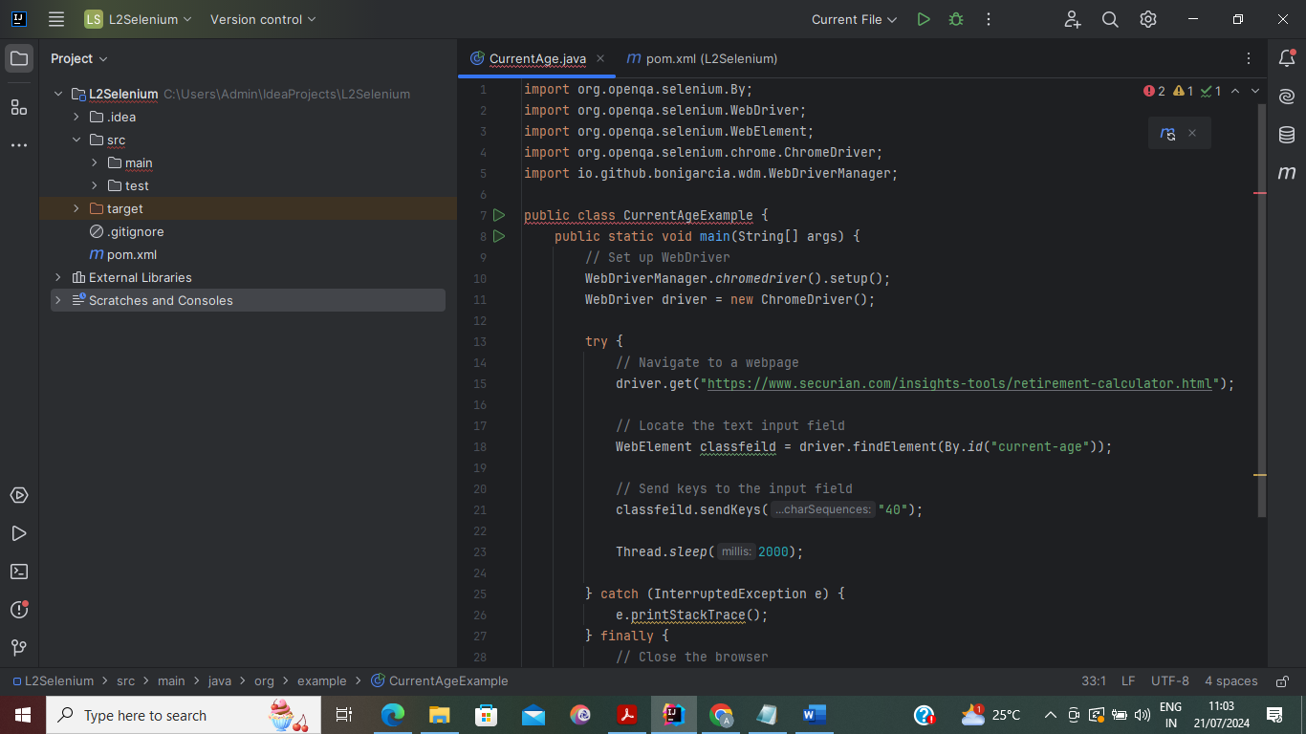
Output:
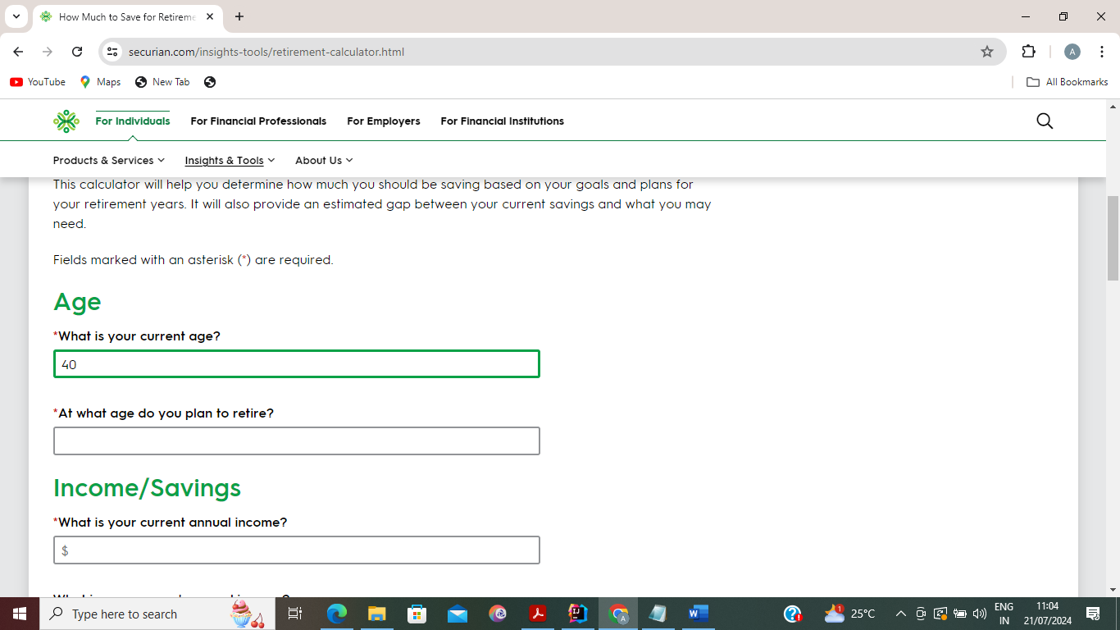

Retirement Age:
TestCase:User can able to open the website(How Much to Save for Retirement | Securian Financial) and fill the value 68(As per Requirement)
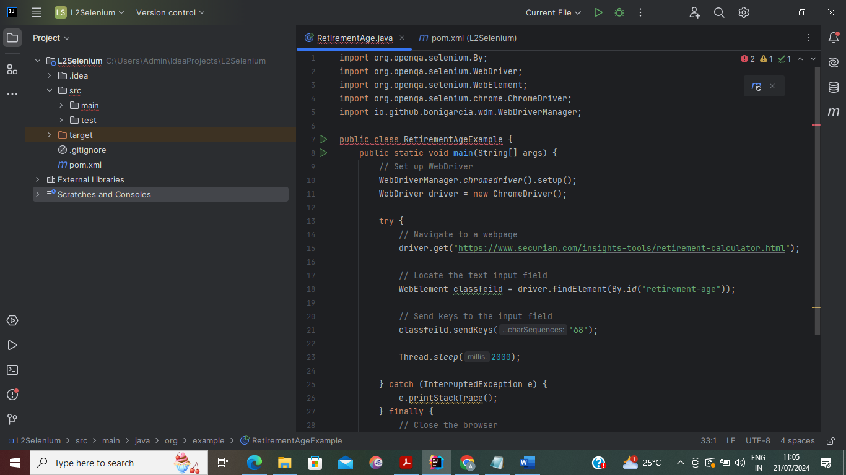
Output:
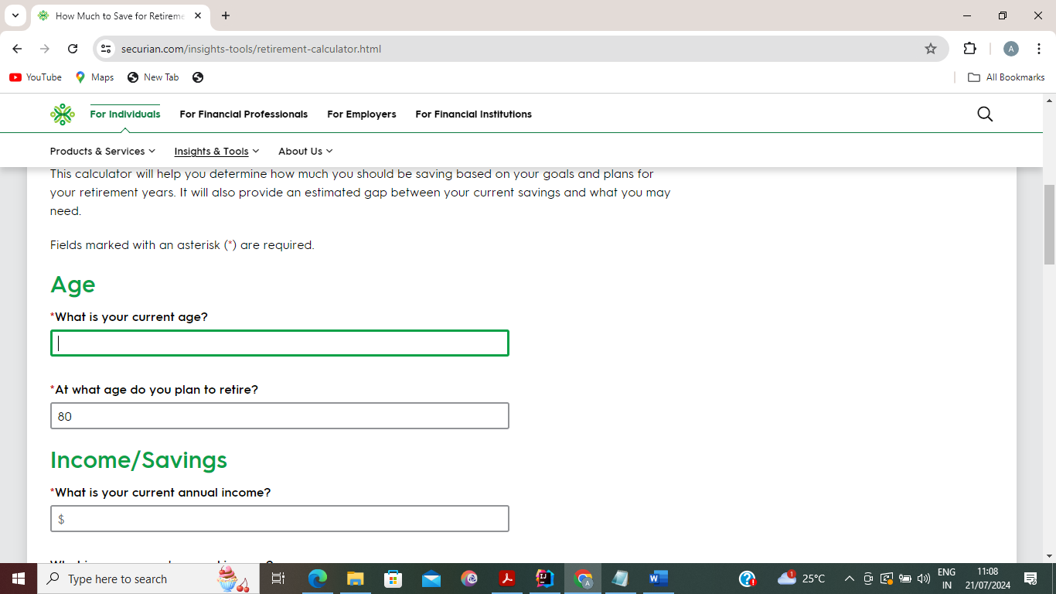
Current Income:
TestCase:User can able to open the website(How Much to Save for Retirement | Securian Financial) and fill the value $100000(As per Requirement)
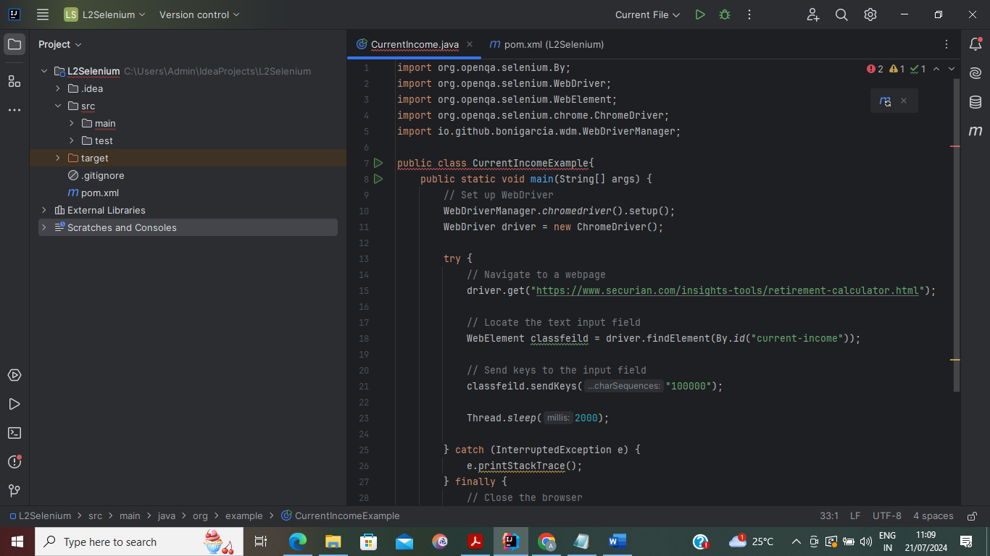
Output: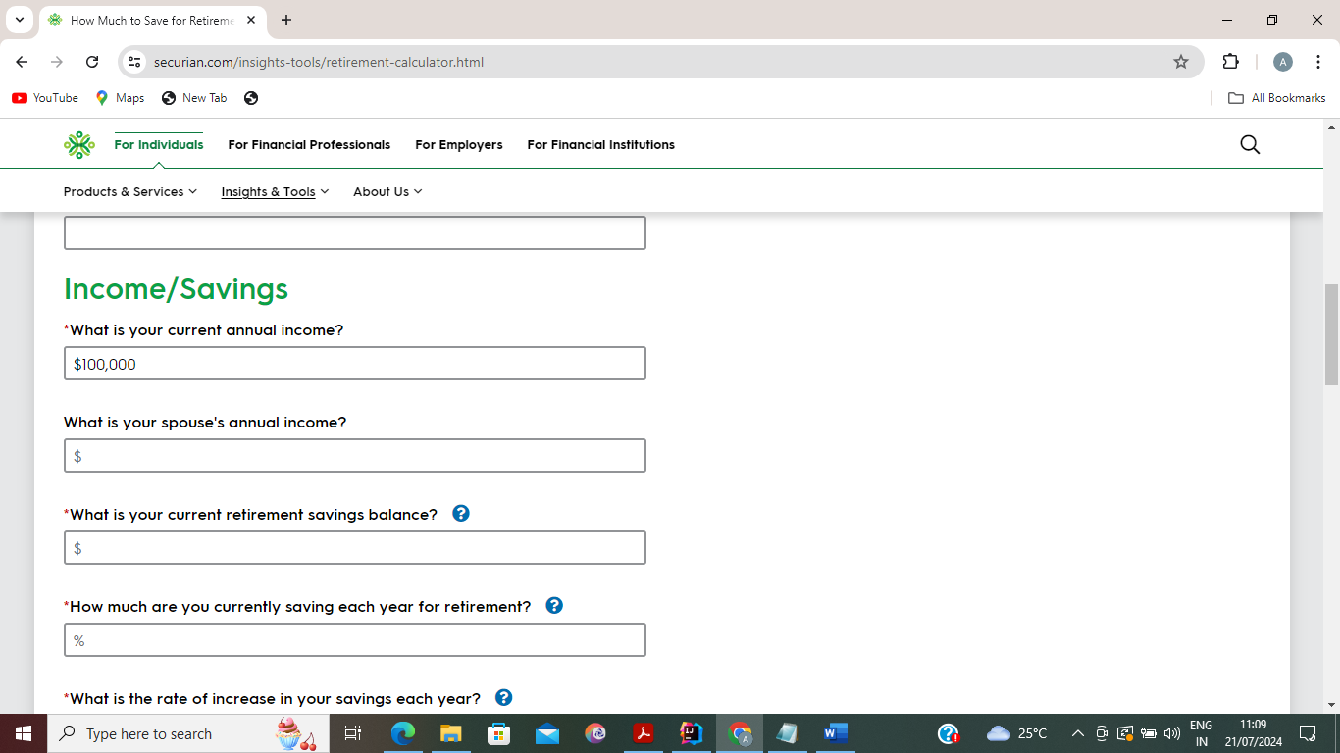
SpouseIncome:
TestCase:User can able to open the website(How Much to Save for Retirement | Securian Financial) and fill the value $100000(As per Requirement) 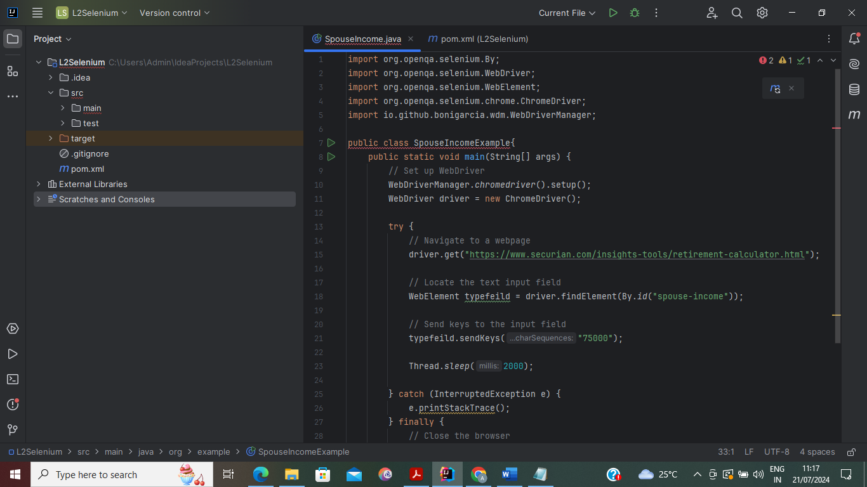
Output:
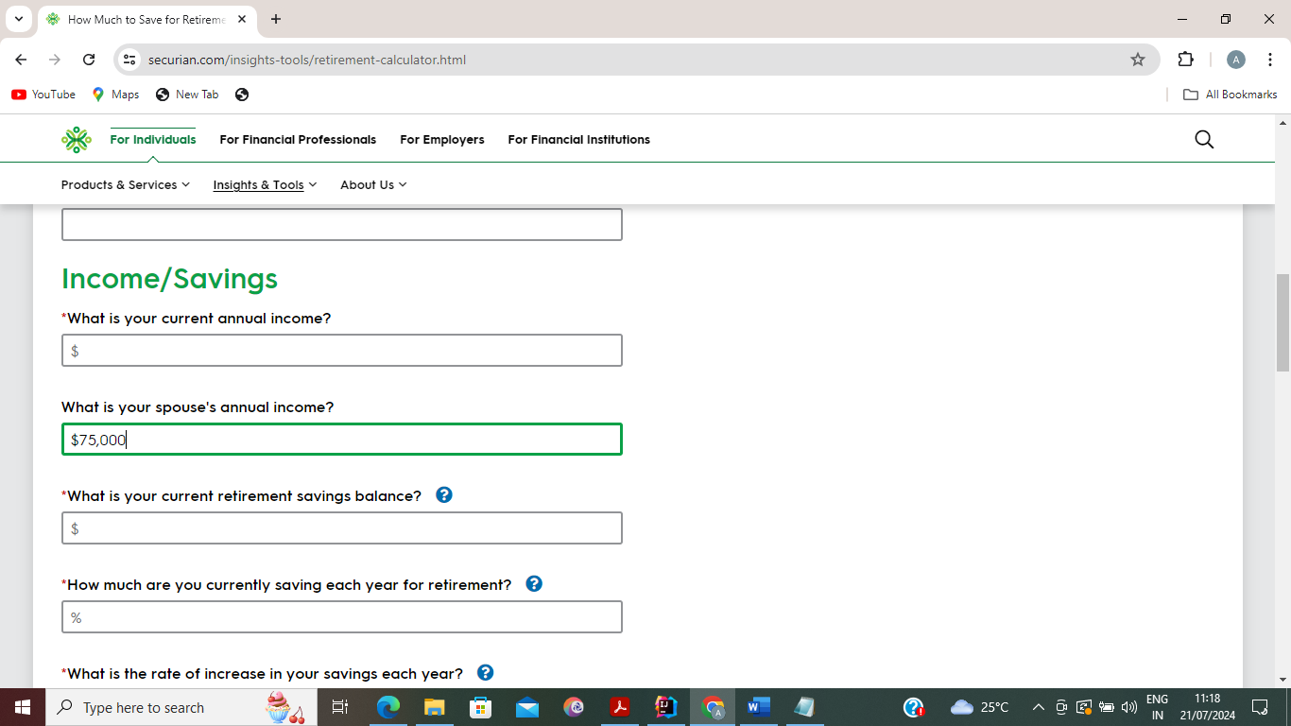
Current Retirement Savings:
TestCase:User can able to open the website(How Much to Save for Retirement | Securian Financial) and fill the value $500000(As per Requirement)
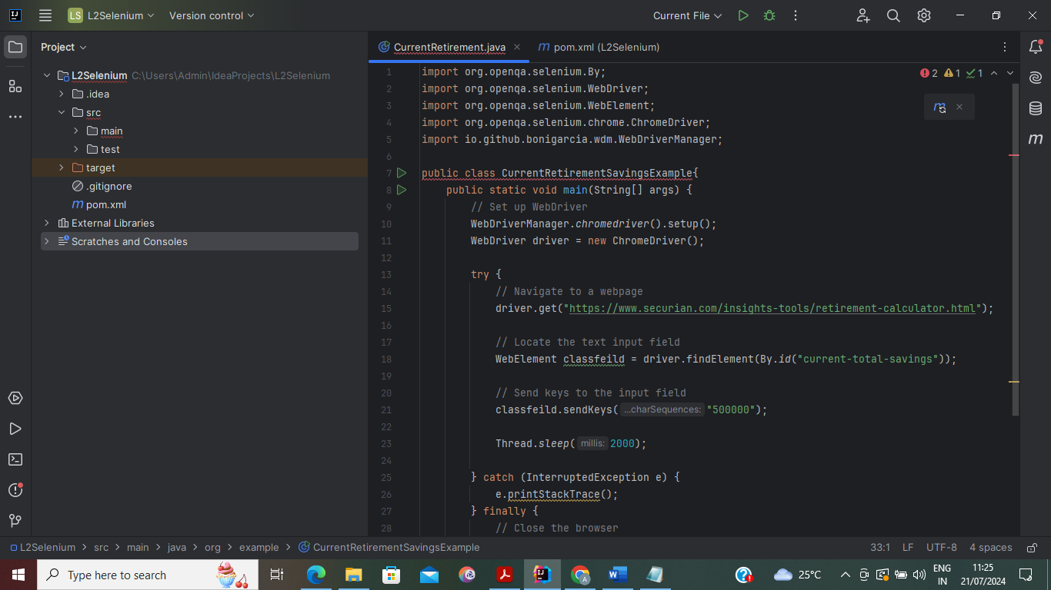
Output:
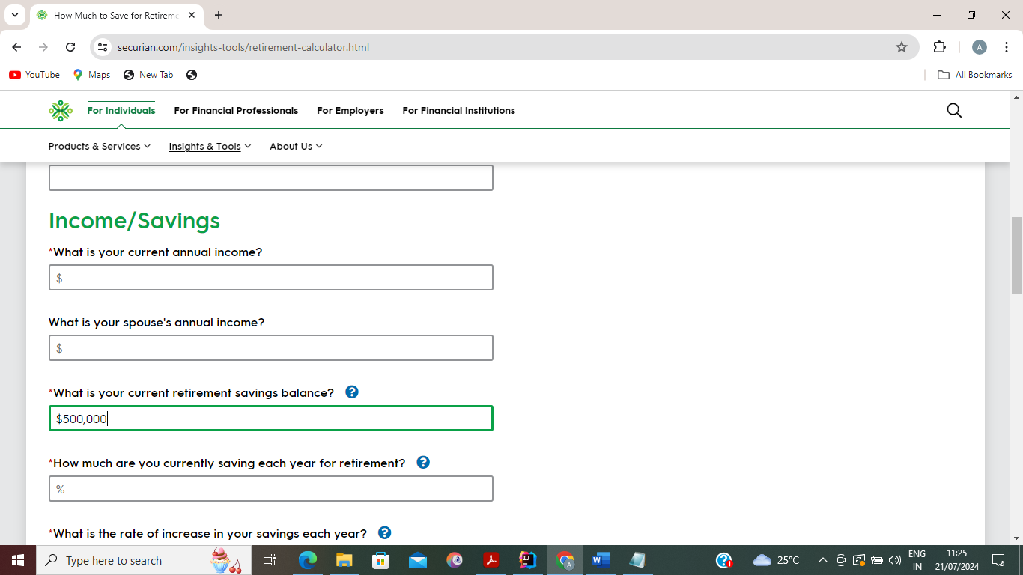
Current Retirement Contribution:
TestCase:User can able to open the website(How Much to Save for Retirement | Securian Financial) and fill the value %10(As per Requirement)
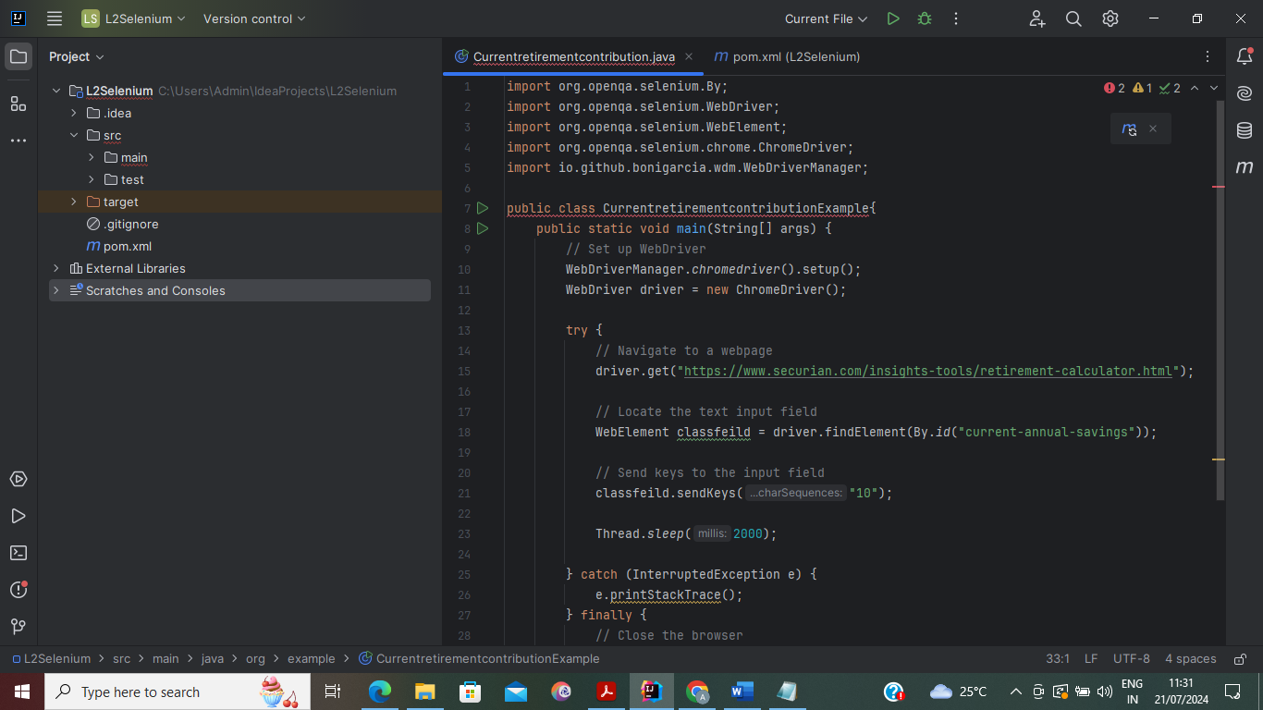
Output:
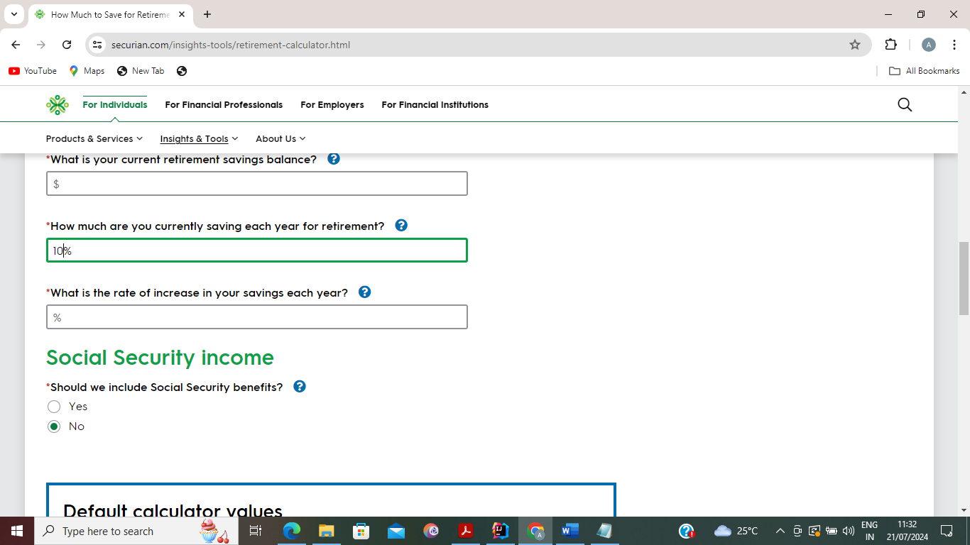
Annual Retirement Contribution Increase:
TestCase:User can able to open the website(How Much to Save for Retirement | Securian Financial) and fill the value %25(As per Requirement)
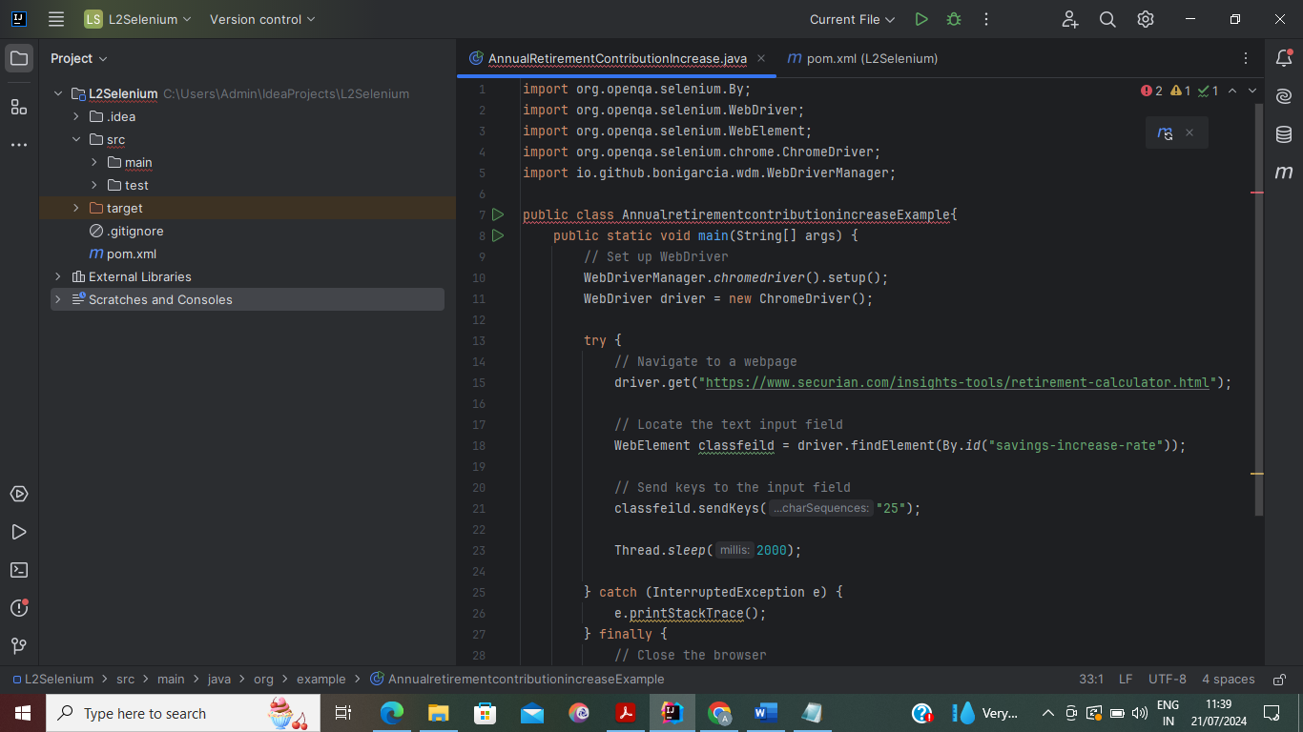
Output:
Here Truncating the value .5
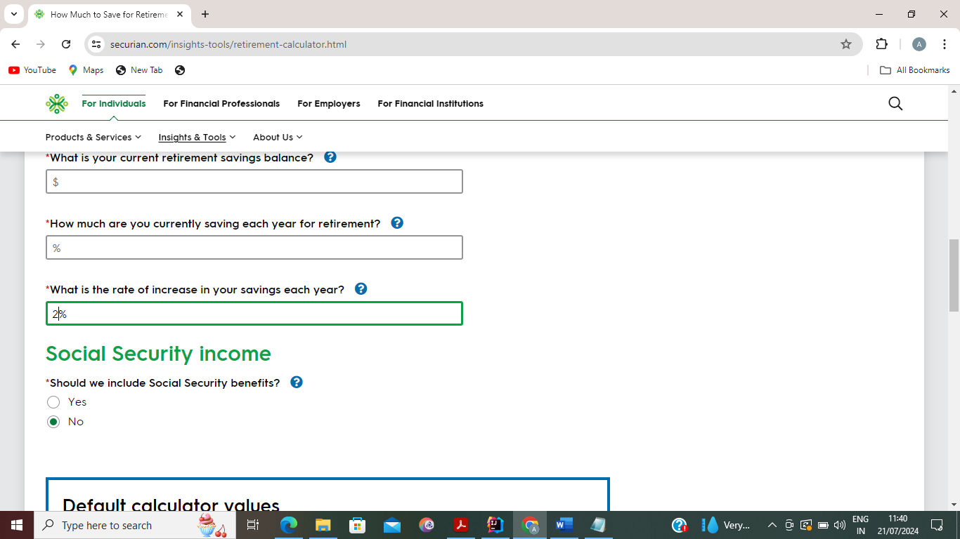

Task2:

Additional Social Security fields should display/hide based on Social Security benefits toggle

Social Security Income

TestCase:User can able to open the website(How Much to Save for Retirement | Securian Financial) and select the radio button-Yes(As per Requirement

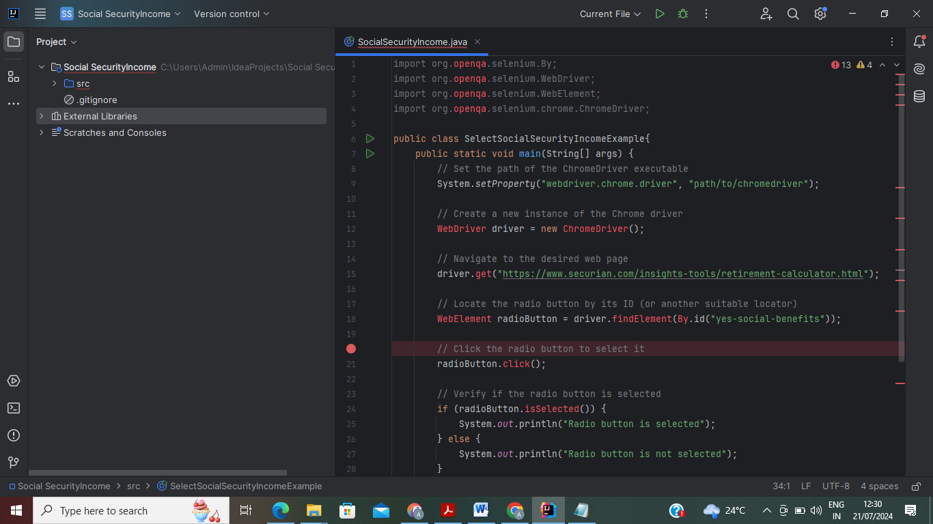
Output:
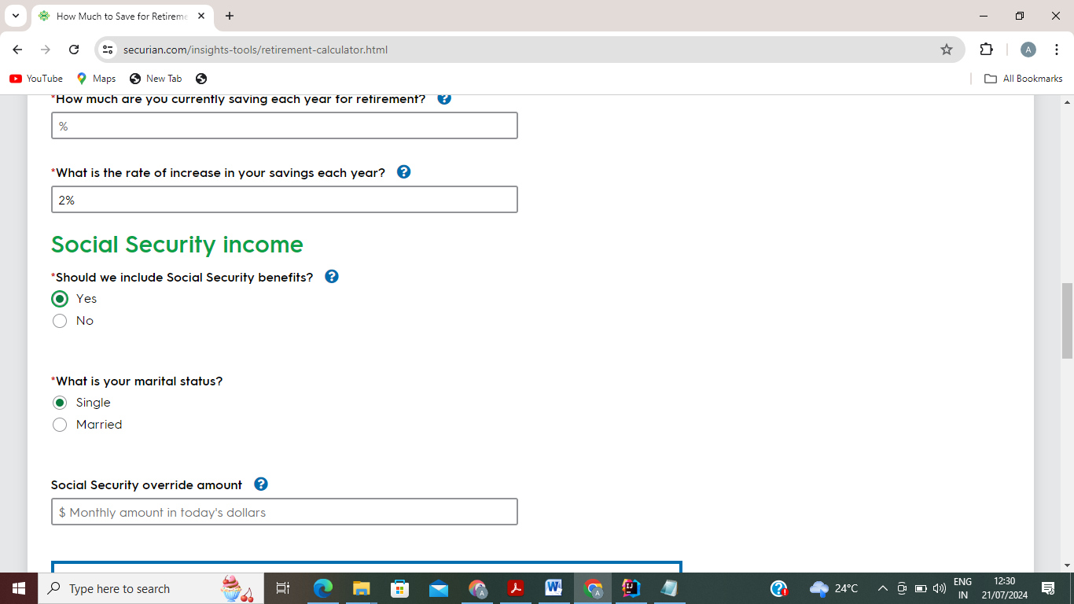

Relationship status:
TestCase:User can able to open the website(How Much to Save for Retirement | Securian Financial) and select the radio button-Married(As per Requirement)

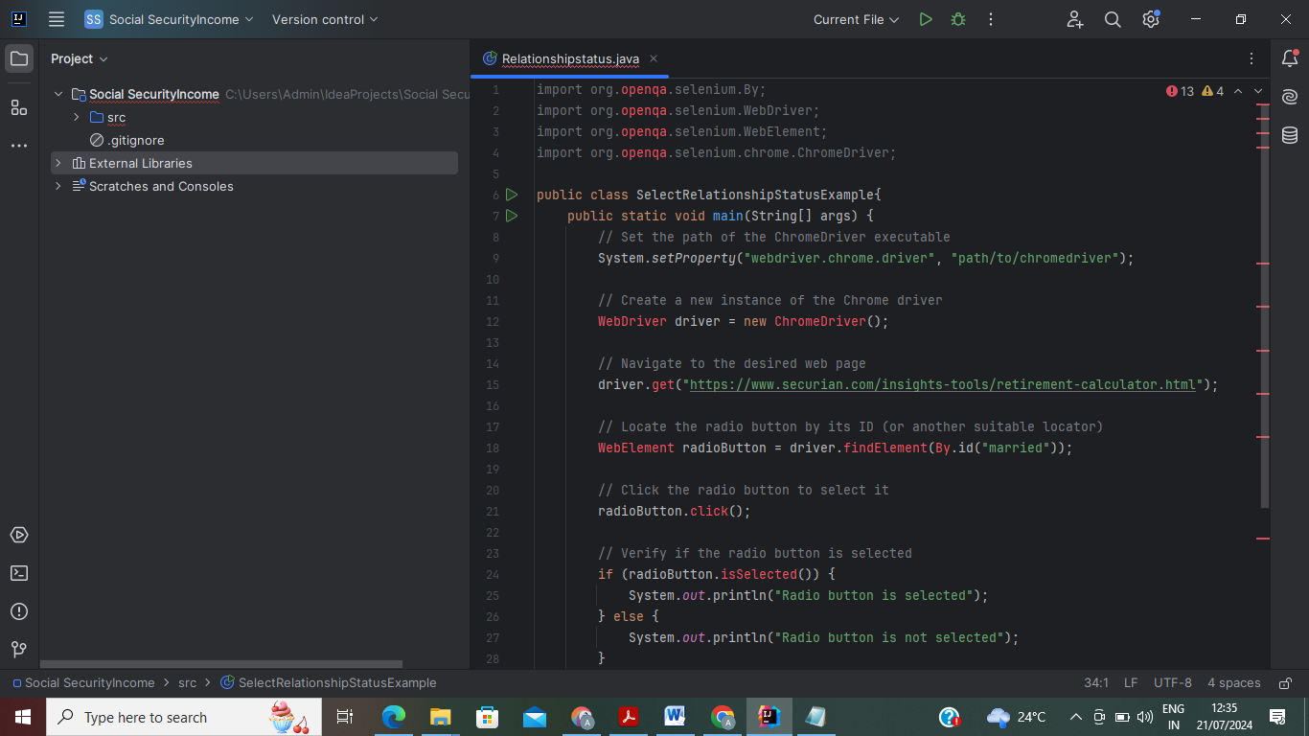
Output:
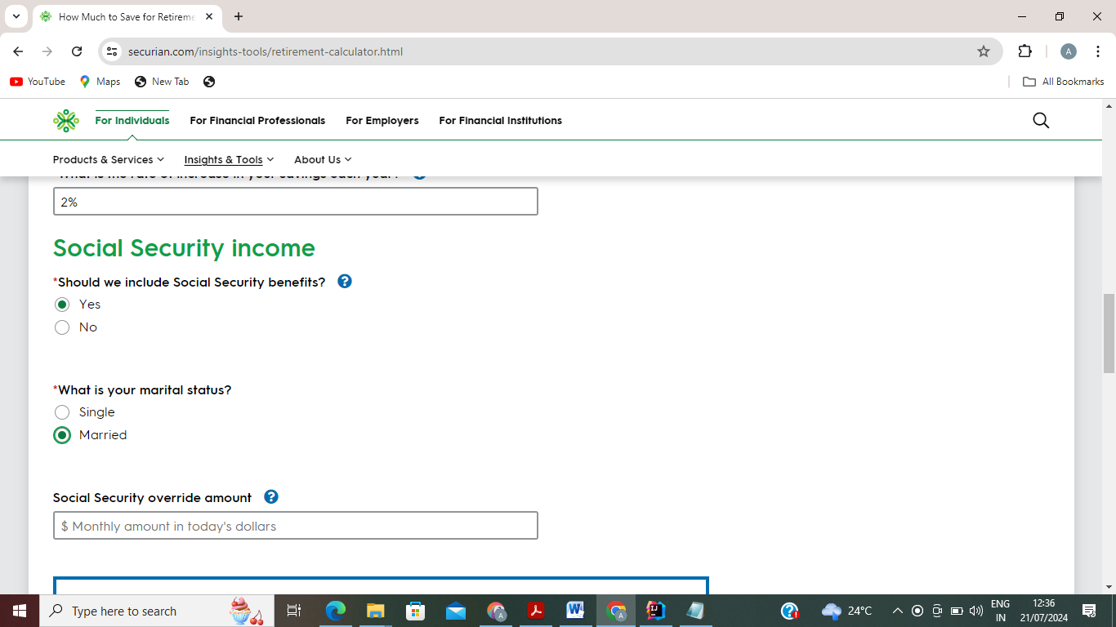
Annual Retirement Contribution Increase:
TestCase:User can able to open the website(How Much to Save for Retirement | Securian Financial) and fill the value $4000(As per Requirement)
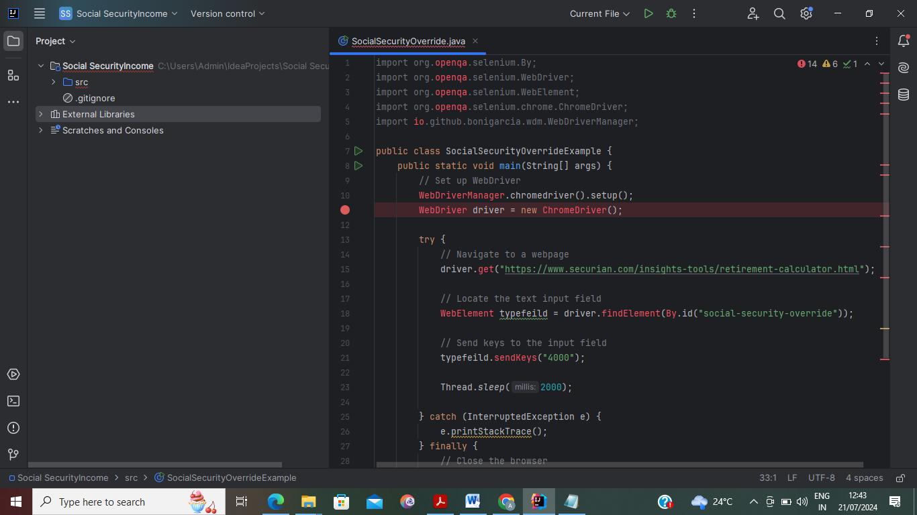
Output:
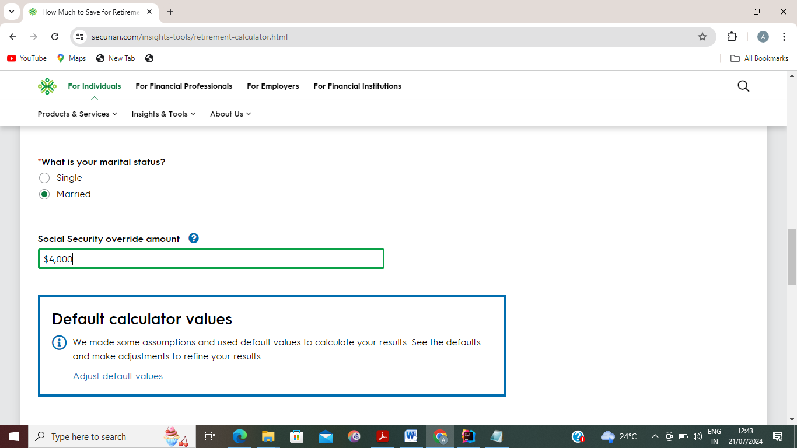
Task 3:

User should be able to update default calculator values
TestCase:User can able to open the website(How Much to Save for Retirement | Securian Financial) and click the link Adjust default values (As per Requirement)
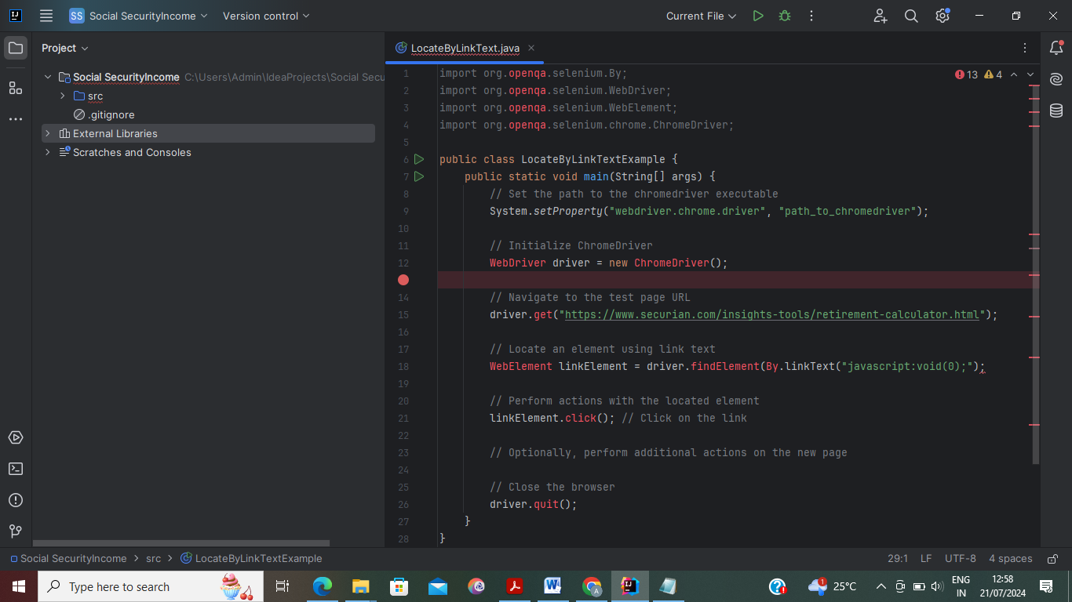
Output:
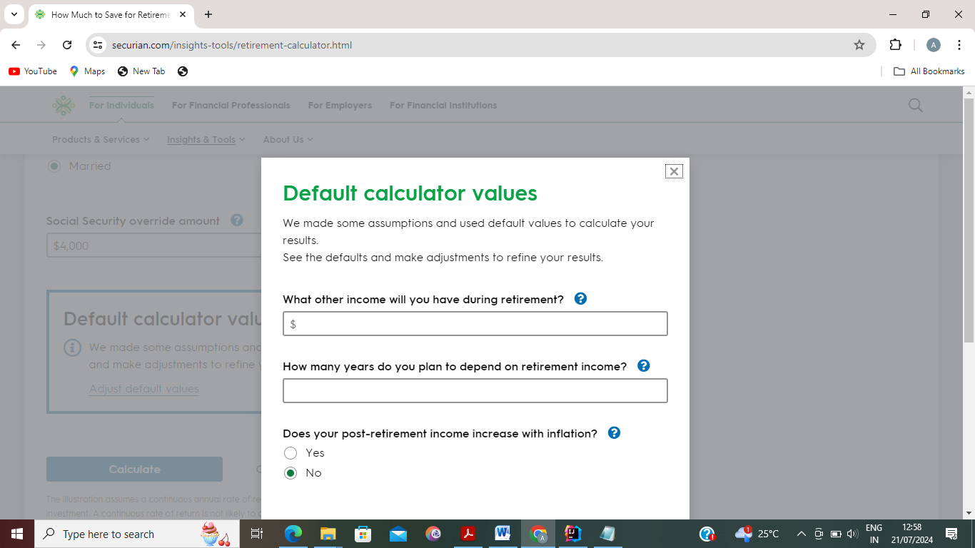

Additional/other income

TestCase:User can able to open the website(How Much to Save for Retirement | Securian Financial) and click the link Adjust default values then fill the value in Other Income-$500(As Per Requirement)
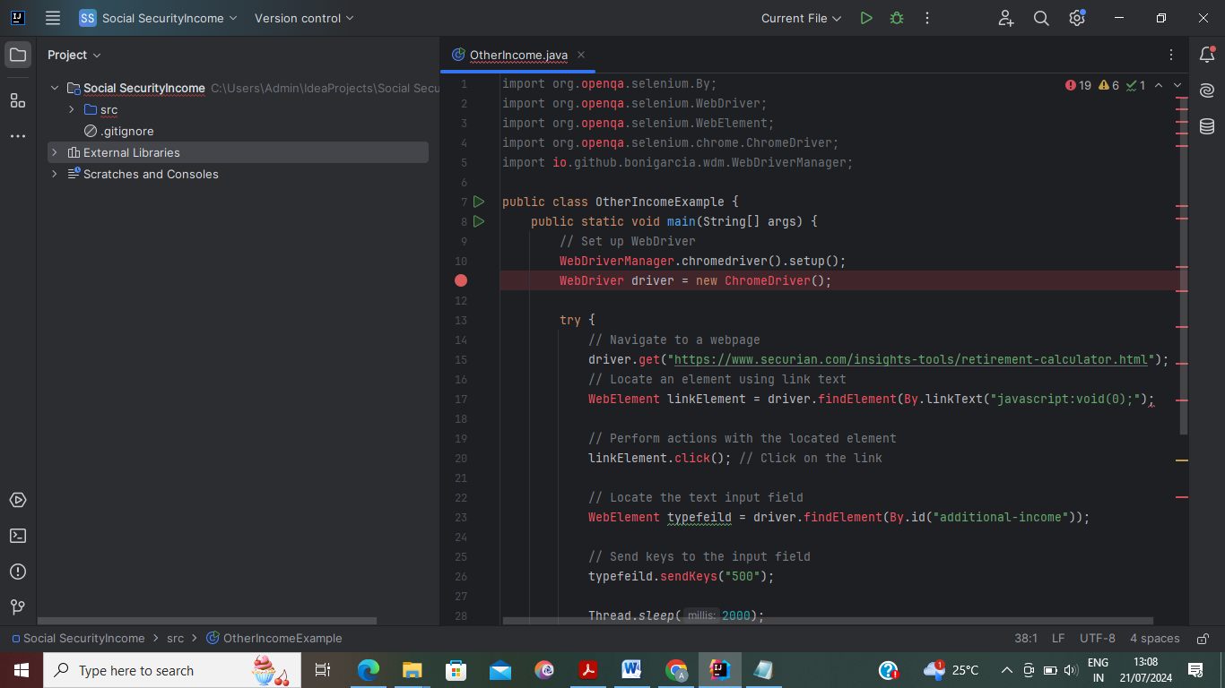
Output:
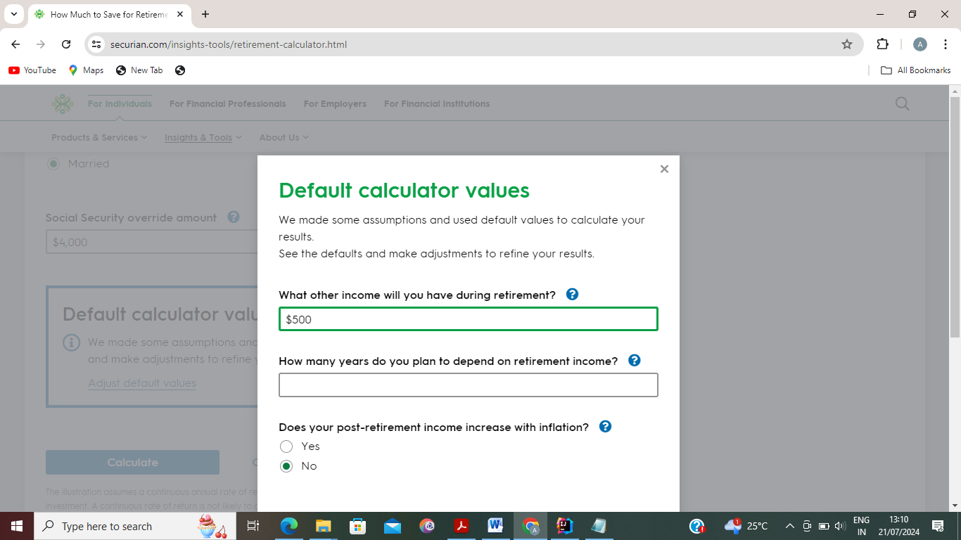

Number of years retirement needs to last

TestCase:User can able to open the website(How Much to Save for Retirement | Securian Financial) and click the link Adjust default values then fill the value in No.of years-20(As Per Requirement)
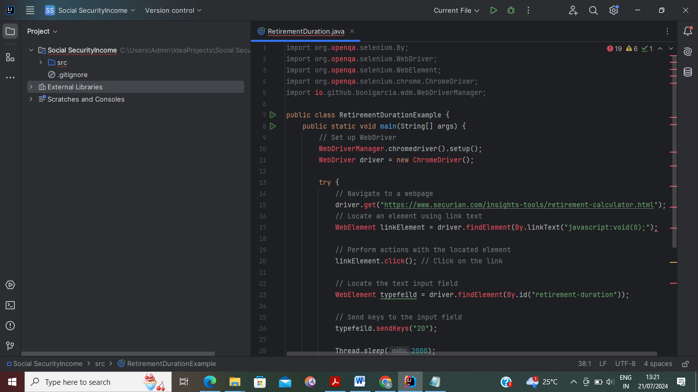
Output:
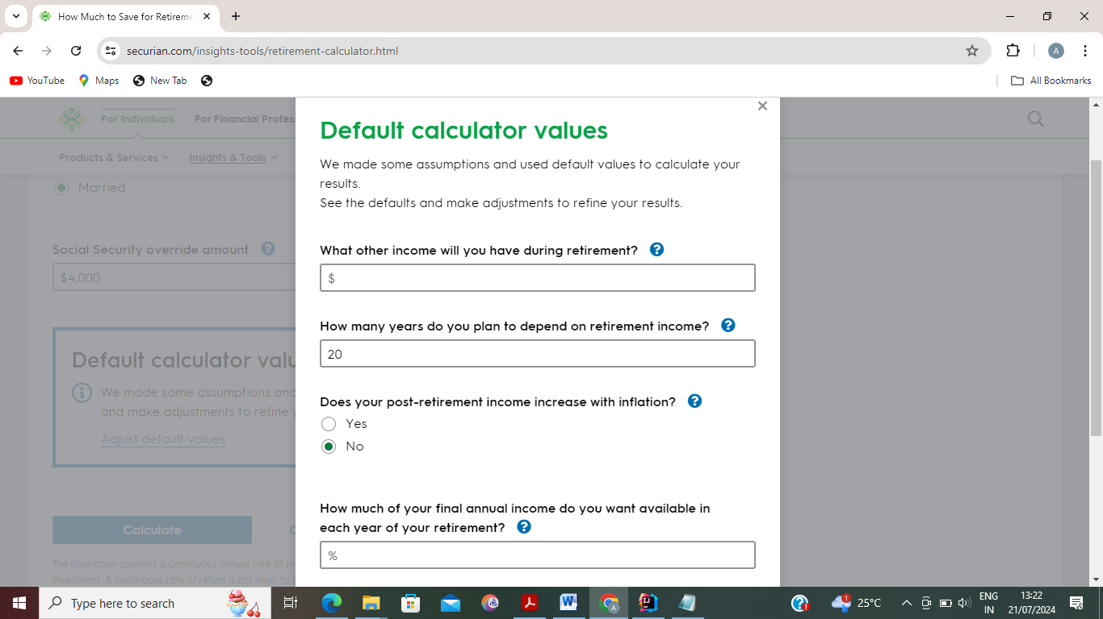

Post-retirement income increase with inflation

TestCase:User can able to open the website(How Much to Save for Retirement | Securian Financial) and click the link Adjust default values then click post-retirement income increase-Yes (As Per Requirement)
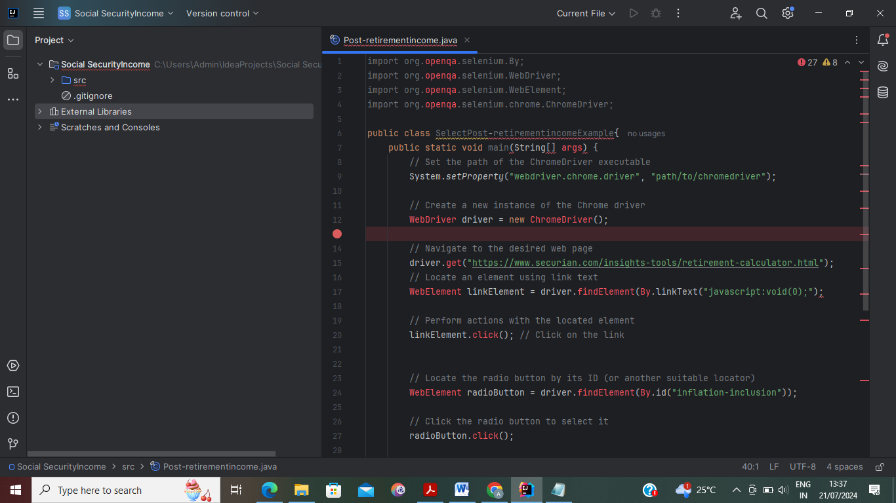
Output:
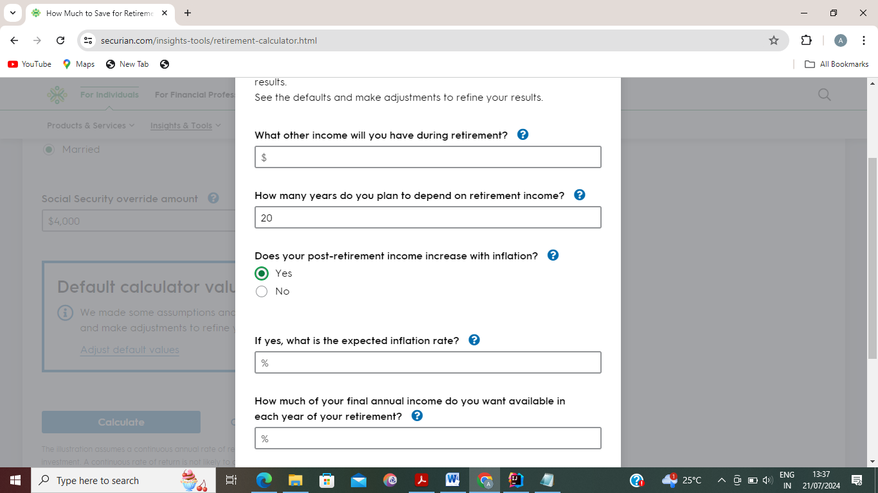

Percent of final annual income desired

TestCase:User can able to open the website(How Much to Save for Retirement | Securian Financial) and click the link Adjust default values then click Final Annual Income-75%(As Per Requirement)
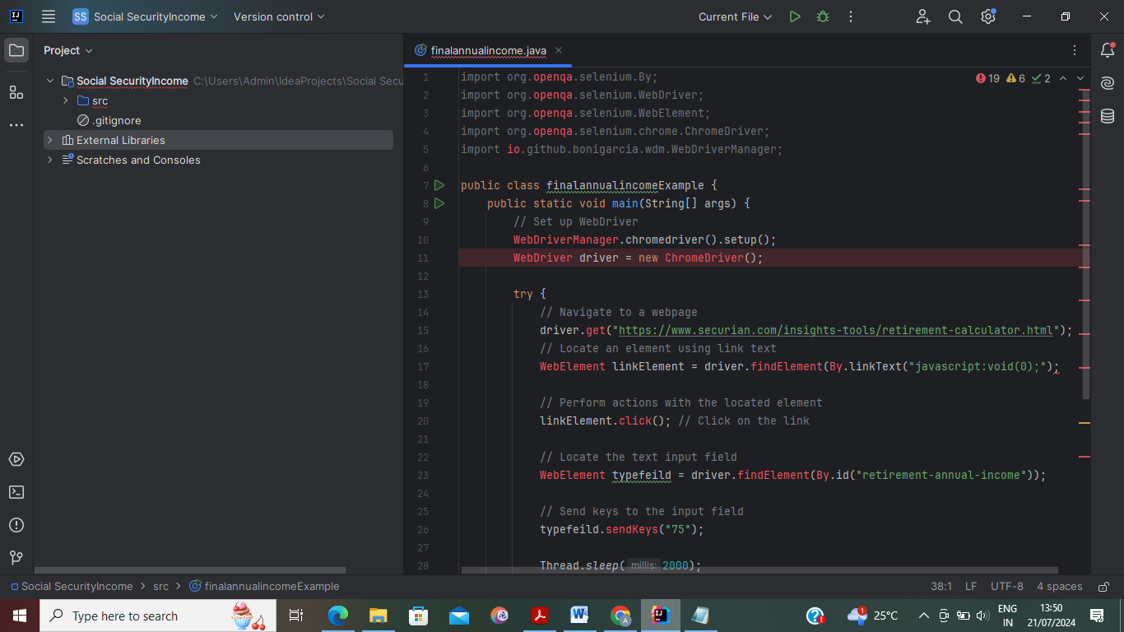

Output:
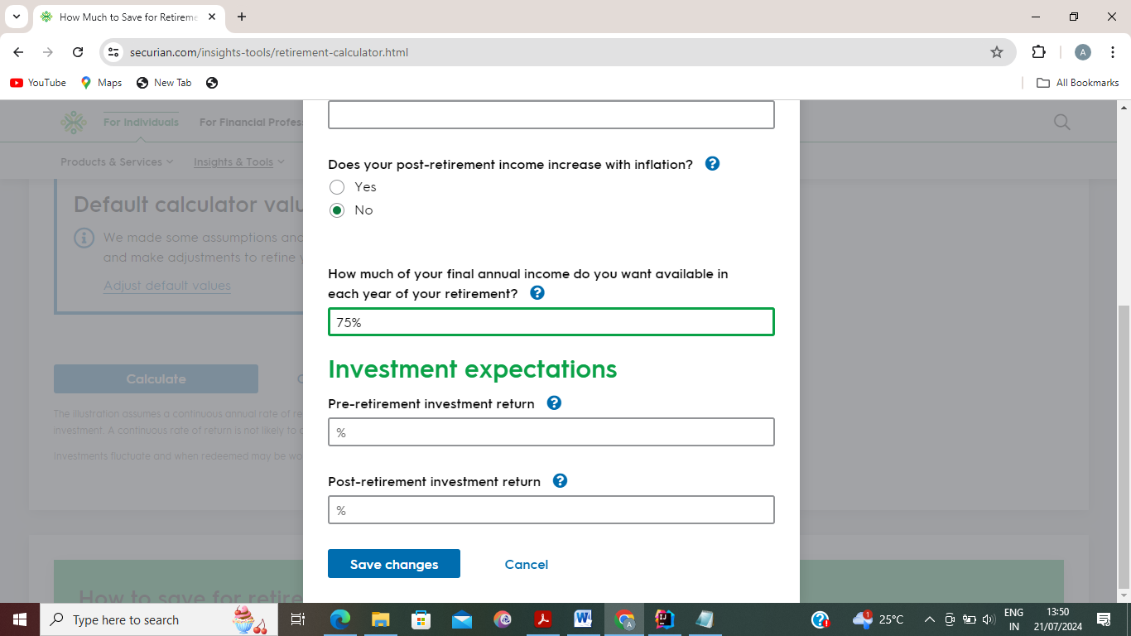

Pre-retirement investment

TestCase:User can able to open the website(How Much to Save for Retirement | Securian Financial) and click the link Adjust default values then click Pre-retirement investment return -8%(As Per Requirement)
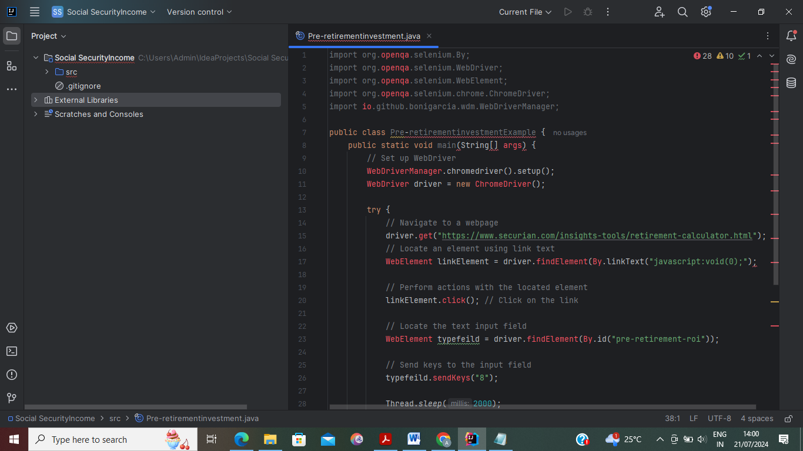
Output:
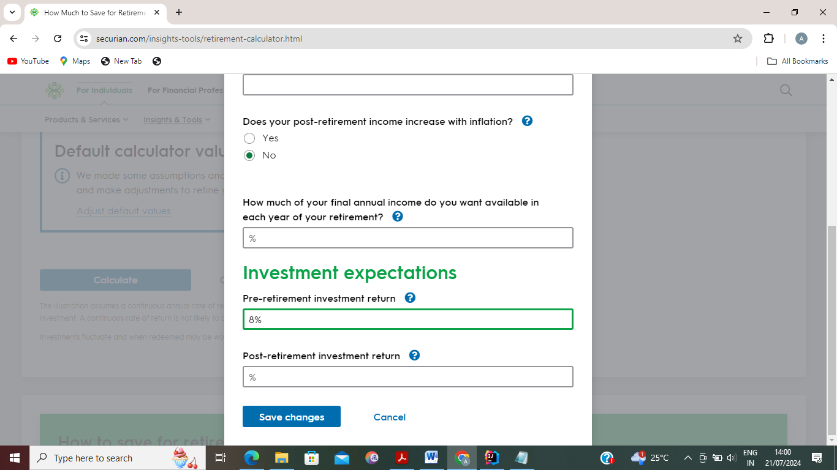
Pot-retirement investment

TestCase:User can able to open the website(How Much to Save for Retirement | Securian Financial) and click the link Adjust default values then click Post-retirement investment return -5%(As Per Requirement)

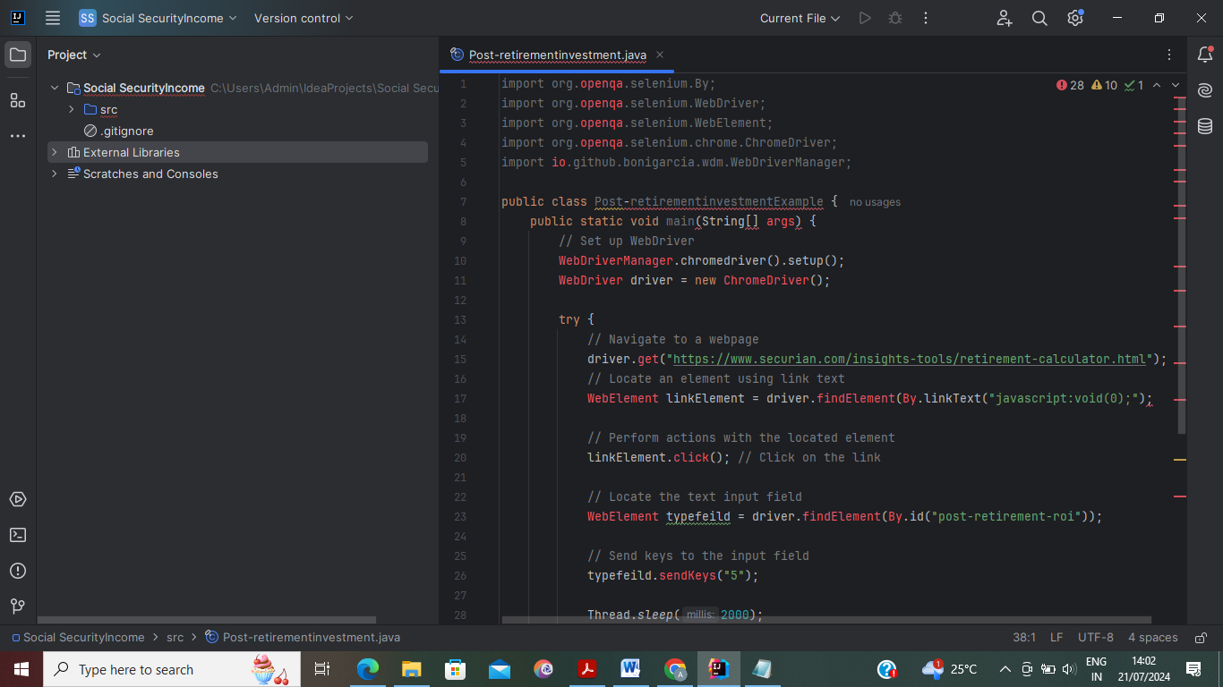
Output:
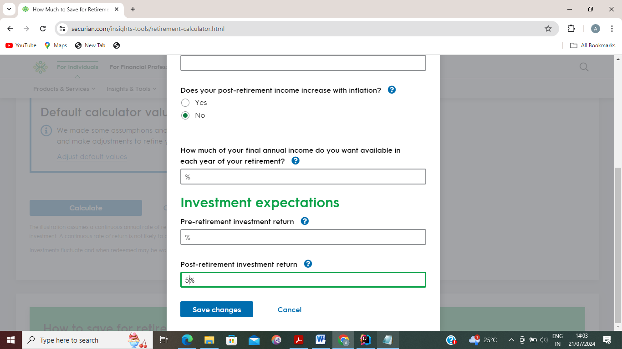
Task4:

User should be able to submit form with all required fields filled in

TestCase:User can able to open the website(How Much to Save for Retirement | Securian Financial) and Fill the values and perform necessary links and Radio buttons to open such as(Calculate/Save changes/Relationship status/Social security benefits)

Field | Value
Current Age | 40
Retirement Age | 68
Current annual income | $100000
Spouse’s annual income | $75000
Current retirement savings | $500000
Current retirement contribution | 10%
Annual retirement contribution increase | .25%
Social Security Income | Yes
Relationship status | Married
Social Security Override | $4000
Additional/other income | $500
Number of years retirement needs to last | 20
Post-retirement income increase with inflation | Yes
Percent of final annual income desired | 75%
Pre-retirement investment return | 8%
Post-retirement investment return | 5%

Output:


